#
# 20200812
# For Ubuntu 18.04.
root@ds-net-qlb01:~# unattended-upgrade -d
...
Packages that will be upgraded: amd64-microcode apport apt apt-utils bind9-host binutils binutils-common binutils-x86-64-linux-gnu busybox-initramfs busybox-static bzip2 ca-certificates clamav clamav-base clamav-freshclam cpio cpp cpp-7 curl dbus dirmngr distro-info-data dnsutils e2fsprogs file g++ g++-7 gcc gcc-7 gcc-7-base gcc-8-base gettext-base git git-man gnupg gnupg-l10n gnupg-utils gpg gpg-agent gpg-wks-client gpg-wks-server gpgconf gpgsm gpgv grub-common grub-pc grub-pc-bin grub2-common initramfs-tools initramfs-tools-bin initramfs-tools-core intel-microcode iproute2 isc-dhcp-client isc-dhcp-common krb5-locales libapt-inst2.0 libapt-pkg5.0 libarchive13 libasan4 libatomic1 libavahi-client3 libavahi-common-data libavahi-common3 libbind9-160 libbinutils libbsd0 libbz2-1.0 libc-bin libc-dev-bin libc6 libc6-dev libcc1-0 libcilkrts5 libclamav9 libcom-err2 libcups2 libcurl3-gnutls libcurl4 libdb5.3 libdbus-1-3 libdns-export1100 libdns1100 libdrm-common libdrm2 libelf1 libexpat1 libexpat1-dev libext2fs2 libgcc-7-dev libgcc1 libgcrypt20 libglib2.0-0 libglib2.0-data libgnutls30 libgomp1 libgssapi-krb5-2 libicu60 libidn2-0 libirs160 libisc-export169 libisc169 libisccc160 libisccfg160 libitm1 libjson-c3 libk5crypto3 libkrb5-3 libkrb5support0 libldap-2.4-2 libldap-common libldb1 liblsan0 liblua5.3-0 liblwres160 libmagic-mgc libmagic1 libmpx2 libmspack0 libmysqlclient20 libnss-systemd libnss3 libntfs-3g88 libpam-systemd libpcap0.8 libperl5.26 libpng16-16 libpolkit-agent-1-0 libpolkit-backend-1-0 libpolkit-gobject-1-0 libpq5 libpython2.7 libpython2.7-minimal libpython2.7-stdlib libpython3.6 libpython3.6-dev libpython3.6-minimal libpython3.6-stdlib libquadmath0 libruby2.5 libsasl2-2 libsasl2-modules libsasl2-modules-db libseccomp2 libsmbclient libsqlite3-0 libss2 libssl1.0.0 libssl1.1 libstdc++-7-dev libstdc++6 libsystemd0 libtsan0 libubsan0 libudev1 libwbclient0 libxml2 libxslt1.1 libzstd1 linux-base linux-firmware linux-libc-dev linux-tools-common locales multiarch-support netplan.io nplan ntfs-3g openssh-client openssh-server openssh-sftp-server openssl patch perl perl-base perl-modules-5.26 policykit-1 python-apt python-apt-common python-ldb python-samba python2.7 python2.7-minimal python3-apport python3-apt python3-cryptography python3-distro-info python3-httplib2 python3-problem-report python3-twisted python3-twisted-bin python3-urllib3 python3.6 python3.6-dev python3.6-minimal rake rsync ruby2.5 samba-common samba-common-bin samba-libs smbclient sudo sysstat systemd systemd-sysv tcpdump tzdata udev vim vim-common vim-runtime vim-tiny wget xxd
Writing dpkg log to /var/log/unattended-upgrades/unattended-upgrades-dpkg.log
...
Log started: 2020-08-12 14:45:53
(Reading database ... 115766 files and directories currently installed.)
Preparing to unpack .../g++_4%3a7.4.0-1ubuntu2.3_amd64.deb ...
Unpacking g++ (4:7.4.0-1ubuntu2.3) over (4:7.3.0-3ubuntu2.1) ...
Processing triggers for man-db (2.8.3-2ubuntu0.1) ...
Setting up g++ (4:7.4.0-1ubuntu2.3) ...
left to upgrade set()
All upgrades installed
InstCount=0 DelCount=0 BrokenCount=0
Extracting content from /var/log/unattended-upgrades/unattended-upgrades-dpkg.log since 2020-08-12 14:08:24
root@ds-net-qlb01:~#

root@ds-net-qlb01:~# apt-get -s dist-upgrade| grep "^Inst" | grep -i security
root@ds-net-qlb01:~# unattended-upgrade -v --dry-run
Initial blacklisted packages:
Initial whitelisted packages:
Starting unattended upgrades script
Allowed origins are: o=Ubuntu,a=bionic, o=Ubuntu,a=bionic-security, o=UbuntuESMApps,a=bionic-apps-security, o=UbuntuESM,a=bionic-infra-security
No packages found that can be upgraded unattended and no pending auto-removals
root@ds-net-qlb01:~#

#
# https://askubuntu.com/questions/194/how-can-i-install-just-security-updates-from-the-command-line
# https://wiki.ubuntu.com/SoftwareUpdates
#

# Make a security updates and get info in debug mode. On Ubuntu 16.04.
#
root@m1-prod-tbru-ts-ssp-core-2:~# unattended-upgrade -d
Initial blacklisted packages:
Initial whitelisted packages:
Starting unattended upgrades script
...
pkgs that look like they should be upgraded: libldb1
libnss3
libnss3-nssdb
libsqlite3-0
libssl1.0.0
openssl
python-ldb
Get:1 http://repo-linux.tcsbank.ru/repository/ubuntu xenial-updates/main amd64 libsqlite3-0 amd64 3.11.0-1ubuntu1.1 [396 kB]
Get:2 http://repo-linux.tcsbank.ru/repository/ubuntu xenial-updates/main amd64 libssl1.0.0 amd64 1.0.2g-1ubuntu4.15 [1084 kB]
Get:3 http://repo-linux.tcsbank.ru/repository/ubuntu xenial-updates/main amd64 openssl amd64 1.0.2g-1ubuntu4.15 [492 kB]
Get:4 http://repo-linux.tcsbank.ru/repository/ubuntu xenial-updates/main amd64 python-ldb amd64 2:1.1.24-1ubuntu3.1 [29.2 kB]
Get:5 http://repo-linux.tcsbank.ru/repository/ubuntu xenial-updates/main amd64 libldb1 amd64 2:1.1.24-1ubuntu3.1 [108 kB]
Get:6 http://repo-linux.tcsbank.ru/repository/ubuntu xenial-updates/main amd64 libnss3-nssdb all 2:3.28.4-0ubuntu0.16.04.5 [10.6 kB]
Get:7 http://repo-linux.tcsbank.ru/repository/ubuntu xenial-updates/main amd64 libnss3 amd64 2:3.28.4-0ubuntu0.16.04.5 [1148 kB]
Fetched 3268 kB in 0s (0 B/s)
...
Author: bsv <bsv@m1-prod-tbru-ts-ssp-core-2.tcsbank.ru>
1 file changed, 10 insertions(+), 10 deletions(-)
Preconfiguring packages ...
(Reading database ... 78631 files and directories currently installed.)
Preparing to unpack .../libsqlite3-0_3.11.0-1ubuntu1.1_amd64.deb ...
Unpacking libsqlite3-0:amd64 (3.11.0-1ubuntu1.1) over (3.11.0-1ubuntu1) ...
Preparing to unpack .../libssl1.0.0_1.0.2g-1ubuntu4.15_amd64.deb ...
Unpacking libssl1.0.0:amd64 (1.0.2g-1ubuntu4.15) over (1.0.2g-1ubuntu4.14) ...
Preparing to unpack .../openssl_1.0.2g-1ubuntu4.15_amd64.deb ...
Unpacking openssl (1.0.2g-1ubuntu4.15) over (1.0.2g-1ubuntu4.14) ...
Preparing to unpack .../python-ldb_2%3a1.1.24-1ubuntu3.1_amd64.deb ...
Unpacking python-ldb (2:1.1.24-1ubuntu3.1) over (2:1.1.24-1ubuntu3) ...
Preparing to unpack .../libldb1_2%3a1.1.24-1ubuntu3.1_amd64.deb ...
Unpacking libldb1:amd64 (2:1.1.24-1ubuntu3.1) over (2:1.1.24-1ubuntu3) ...
Preparing to unpack .../libnss3-nssdb_2%3a3.28.4-0ubuntu0.16.04.5_all.deb ...
Unpacking libnss3-nssdb (2:3.28.4-0ubuntu0.16.04.5) over (2:3.28.4-0ubuntu0.16.04.4) ...
Preparing to unpack .../libnss3_2%3a3.28.4-0ubuntu0.16.04.5_amd64.deb ...
Unpacking libnss3:amd64 (2:3.28.4-0ubuntu0.16.04.5) over (2:3.28.4-0ubuntu0.16.04.4) ...
Processing triggers for libc-bin (2.23-0ubuntu11) ...
Processing triggers for man-db (2.7.5-1) ...
Setting up libsqlite3-0:amd64 (3.11.0-1ubuntu1.1) ...
Setting up libssl1.0.0:amd64 (1.0.2g-1ubuntu4.15) ...
Setting up openssl (1.0.2g-1ubuntu4.15) ...
Setting up libldb1:amd64 (2:1.1.24-1ubuntu3.1) ...
Setting up python-ldb (2:1.1.24-1ubuntu3.1) ...
Setting up libnss3-nssdb (2:3.28.4-0ubuntu0.16.04.5) ...
Setting up libnss3:amd64 (2:3.28.4-0ubuntu0.16.04.5) ...
Processing triggers for libc-bin (2.23-0ubuntu11) ...
All upgrades installed
InstCount=0 DelCount=0 BrokenCount=0
Extracting content from '/var/log/unattended-upgrades/unattended-upgrades-dpkg.log' since '2019-03-01 14:45:05'
root@m1-prod-tbru-ts-ssp-core-2:~#

# To use with verbose mode and in test only mode.
root@m1-prod-tbru-ts-ssp-core-2:~# unattended-upgrade -v --dry-run
Initial blacklisted packages:
Initial whitelisted packages:
Starting unattended upgrades script
Allowed origins are: ['o=Ubuntu,a=xenial', 'o=Ubuntu,a=xenial-security', 'o=UbuntuESM,a=xenial']
No packages found that can be upgraded unattended and no pending auto-removals
root@m1-prod-tbru-ts-ssp-core-2:~#

# To use with verbose mode and in test only mode.
root@m1-prod-tbru-ts-ssp-core-2:~# unattended-upgrade -v
Initial blacklisted packages:
Initial whitelisted packages:
Starting unattended upgrades script
Allowed origins are: ['o=Ubuntu,a=xenial', 'o=Ubuntu,a=xenial-security', 'o=UbuntuESM,a=xenial']
No packages found that can be upgraded unattended and no pending auto-removals
root@m1-prod-tbru-ts-ssp-core-2:~#

#
# “-d” - for debug information.
#
root@m1-prod-tbru-ts-ssp-core-2:~# unattended-upgrade -d --dry-run
Initial blacklisted packages:
Initial whitelisted packages:
Starting unattended upgrades script
Allowed origins are: ['o=Ubuntu,a=xenial', 'o=Ubuntu,a=xenial-security', 'o=UbuntuESM,a=xenial']
pkgs that look like they should be upgraded:
Fetched 0 B in 0s (0 B/s)
fetch.run() result: 0
blacklist: []
whitelist: []
No packages found that can be upgraded unattended and no pending auto-removals
root@m1-prod-tbru-ts-ssp-core-2:~#

root@m1-prod-tbru-ts-ssp-core-2:~# unattended-upgrade --help
Usage: unattended-upgrade [options]

Options:
-h, --help show this help message and exit
-d, --debug print debug messages
--apt-debug make apt/libapt print verbose debug messages
-v, --verbose print info messages
--dry-run Simulation, download but do not install
--download-only Only download, do not even try to install.
--minimal-upgrade-steps
Upgrade in minimal steps (and allow interrupting with
SIGINT
root@m1-prod-tbru-ts-ssp-core-2:~#

#
# Here is somtime placed a cron task, that run upgrade periodically. But on this system ubuntu 16.04 this task is absent.
#
root@m1-prod-tbru-ts-ssp-core-2:~# cat /etc/cron.daily/apt
cat: /etc/cron.daily/apt: No such file or directory
root@m1-prod-tbru-ts-ssp-core-2:~# ls -Alh /etc/cron.daily/
total 60K
-rwxr-xr-x 1 root root 376 Mar 31 2016 apport
-rwxr-xr-x 1 root root 1.5K Feb 27 2017 apt-compat
-rwxr-xr-x 1 root root 355 May 22 2012 bsdmainutils
-rwxr-xr-x 1 root root 1.6K Nov 27 2015 dpkg
-rwxr-xr-x 1 root root 589 Aug 4 2015 etckeeper
-rwxr-xr-x 1 root root 372 May 6 2015 logrotate
-rwxr-xr-x 1 root root 1.3K Nov 6 2015 man-db
-rwxr-xr-x 1 root root 539 Jul 16 2014 mdadm
-rwxr-xr-x 1 root root 435 Nov 18 2014 mlocate
-rwxr-xr-x 1 root root 1.4K Oct 5 2016 ntp
-rwxr-xr-x 1 root root 249 Nov 13 2015 passwd
-rw-r--r-- 1 root root 102 Apr 6 2016 .placeholder
-rwxr-xr-x 1 root root 3.4K Feb 26 2016 popularity-contest
-rwxr-xr-x 1 root root 441 Jan 28 2016 sysstat
-rwxr-xr-x 1 root root 214 May 24 2016 update-notifier-common
root@m1-prod-tbru-ts-ssp-core-2:~#

#
# Onother differ way to get some info about security updates.
root@m1-prod-tbru-ts-ssp-core-2:~# apt-get -s dist-upgrade | grep "^Inst" | grep -i securi
root@m1-prod-tbru-ts-ssp-core-2:~#
root@m1-prod-tbru-ts-ssp-core-2:~# apt-get -s dist-upgrade
Reading package lists... Done
Building dependency tree
Reading state information... Done
Calculating upgrade... Done
0 upgraded, 0 newly installed, 0 to remove and 0 not upgraded.
root@m1-prod-tbru-ts-ssp-core-2:~#

root@m1-prod-tbru-ts-ssp-core-2:~# /usr/lib/update-notifier/apt-check -p
root@m1-prod-tbru-ts-ssp-core-2:~#

root@m1-prod-tbru-ts-ssp-core-2:~# checkrestart -v
The program 'checkrestart' is currently not installed. You can install it by typing:
apt install debian-goodies
root@m1-prod-tbru-ts-ssp-core-2:~#

# 20180914
# SD#1732795
Белогруд Сергей Владимирович
На согласование к владельцам серверов:
vm-qa1-tbru-ts-dsp-core-1.tcsbank.ru, vm-qa1-tbru-ts-ssp-core-1.tcsbank.ru

Согласовываете обновление версий ПО на серверах?
Риски - неработоспособность или появление сбоев в работе прикладного ПО на серверах. Гарантий, что обновление ни на что не повлияет вам никто не даст.​ За всеми уточниниями обращаться к инфобесам - инициаторам.
Сегодня в 16:55

# 20180910
# SD#1717088
Белогруд Сергей Владимирович
Владельцы сервера m1-pr-pg-currency01 - согласовываете обновление всех перечисленных в отчёте пакетов? Риски - не работоспособность прикладного ПО или его не корректная работа.
Гарантировать, что ничего не сломается вам, естественно, никто не сможет - это в принципе не возможно.
Все вопросы к безопаси. Их комментарий ниже.
10.09.2018 в 15:15

#
# 20181001
# SD#1732795
# https://sd.tcsbank.ru/0/NUI/ViewModule.aspx#CardModuleV2/CasePage/edit/8168127c-5bd7-4142-9ce4-b95d900f7bb3
#

# How it was on 14.09.2018
root@vm-qa1-tbru-ts-dsp-core-1:~# apt-get install unattended-upgrades

root@vm-qa1-tbru-ts-dsp-core-1:~# unattended-upgrade -d
Initial blacklisted packages:
Initial whitelisted packages:
Starting unattended upgrades script
Allowed origins are: ['o=Ubuntu,a=xenial', 'o=Ubuntu,a=xenial-security', 'o=UbuntuESM,a=xenial']
adjusting candidate version: 'grub-legacy-ec2=0.7.7~bzr1212-0ubuntu1'
adjusting candidate version: 'libsmbclient=2:4.3.11+dfsg-0ubuntu0.16.04.15'
adjusting candidate version: 'libwbclient0=2:4.3.11+dfsg-0ubuntu0.16.04.15'
adjusting candidate version: 'open-iscsi=2.0.873+git0.3b4b4500-14ubuntu3'
adjusting candidate version: 'python-samba=2:4.3.11+dfsg-0ubuntu0.16.04.15'
adjusting candidate version: 'python3-urllib3=1.13.1-2'
adjusting candidate version: 'samba-common=2:4.3.11+dfsg-0ubuntu0.16.04.15'
adjusting candidate version: 'samba-common-bin=2:4.3.11+dfsg-0ubuntu0.16.04.15'
adjusting candidate version: 'samba-libs=2:4.3.11+dfsg-0ubuntu0.16.04.15'
adjusting candidate version: 'smbclient=2:4.3.11+dfsg-0ubuntu0.16.04.15'
adjusting candidate version: 'squashfs-tools=1:4.3-3ubuntu2'
adjusting candidate version: 'x11-common=1:7.7+13ubuntu3'
Checking: libtirpc1 ([<Origin component:'main' archive:'xenial-updates' origin:'Ubuntu' label:'Ubuntu' site:'repo-linux.tcsbank.ru' isTrusted:True>, <Origin component:'main' archive:'xenial-security' origin:'Ubuntu' label:'Ubuntu' site:'repo-linux.tcsbank.ru' isTrusted:True>])
Checking: puppet-agent ([<Origin component:'puppet5' archive:'xenial' origin:'Puppetlabs' label:'Puppetlabs' site:'repo-linux.tcsbank.ru' isTrusted:True>])
pkgs that look like they should be upgraded: libtirpc1
Fetched 0 B in 0s (0 B/s)
fetch.run() result: 0
<apt_pkg.AcquireItem object:Status: 2 Complete: 1 Local: 1 IsTrusted: 1 FileSize: 75442 DestFile:'/var/cache/apt/archives/libtirpc1_0.2.5-1ubuntu0.1_amd64.deb' DescURI: 'http://repo-linux.tcsbank.ru/ubuntu/pool/main/libt/libtirpc/libtirpc1_0.2.5-1ubuntu0.1_amd64.deb' ID:0 ErrorText: ''>
check_conffile_prompt('/var/cache/apt/archives/libtirpc1_0.2.5-1ubuntu0.1_amd64.deb')
found pkg: libtirpc1
conffile line: '/etc/netconfig ca8db53e3af4d735335c2607d21c7195'
current md5: ca8db53e3af4d735335c2607d21c7195
blacklist: []
whitelist: []
Packages that will be upgraded: libtirpc1
Writing dpkg log to '/var/log/unattended-upgrades/unattended-upgrades-dpkg.log'
(Reading database ... 78070 files and directories currently installed.)
Preparing to unpack .../libtirpc1_0.2.5-1ubuntu0.1_amd64.deb ...
Unpacking libtirpc1:amd64 (0.2.5-1ubuntu0.1) over (0.2.5-1) ...
Processing triggers for libc-bin (2.23-0ubuntu10) ...
Processing triggers for man-db (2.7.5-1) ...
Setting up libtirpc1:amd64 (0.2.5-1ubuntu0.1) ...
Processing triggers for libc-bin (2.23-0ubuntu10) ...
All upgrades installed
adjusting candidate version: 'grub-legacy-ec2=0.7.7~bzr1212-0ubuntu1'
adjusting candidate version: 'libsmbclient=2:4.3.11+dfsg-0ubuntu0.16.04.15'
adjusting candidate version: 'libwbclient0=2:4.3.11+dfsg-0ubuntu0.16.04.15'
adjusting candidate version: 'open-iscsi=2.0.873+git0.3b4b4500-14ubuntu3'
adjusting candidate version: 'python-samba=2:4.3.11+dfsg-0ubuntu0.16.04.15'
adjusting candidate version: 'python3-urllib3=1.13.1-2'
adjusting candidate version: 'samba-common=2:4.3.11+dfsg-0ubuntu0.16.04.15'
adjusting candidate version: 'samba-common-bin=2:4.3.11+dfsg-0ubuntu0.16.04.15'
adjusting candidate version: 'samba-libs=2:4.3.11+dfsg-0ubuntu0.16.04.15'
adjusting candidate version: 'smbclient=2:4.3.11+dfsg-0ubuntu0.16.04.15'
adjusting candidate version: 'squashfs-tools=1:4.3-3ubuntu2'
adjusting candidate version: 'x11-common=1:7.7+13ubuntu3'
InstCount=0 DelCount=0 BrokenCount=0
Extracting content from '/var/log/unattended-upgrades/unattended-upgrades-dpkg.log' since '2018-09-1416:48:30'
root@vm-qa1-tbru-ts-dsp-core-1:~#

# How it’s now 01.10.2018.
# I see no available updates.
#
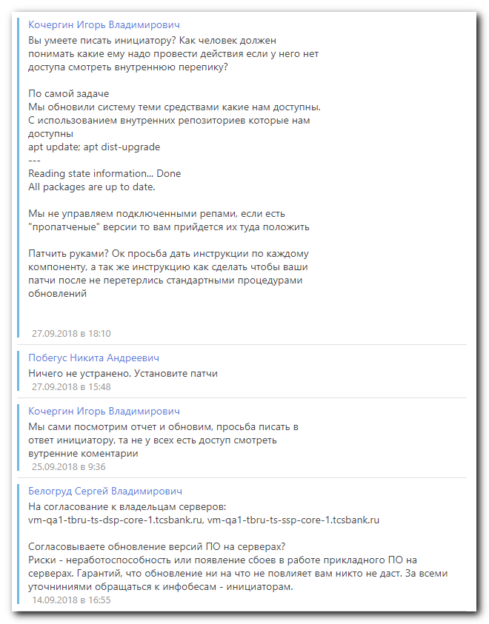

root@vm-qa1-tbru-ts-dsp-core-1:~# apt-get install unattended-upgrades
Reading package lists... Done
Building dependency tree
Reading state information... Done
unattended-upgrades is already the newest version (0.90ubuntu0.9).
The following packages were automatically installed and are no longer required:
gsfonts gsfonts-x11 java-common libfontenc1 libxfont1 x11-common xfonts-encodings xfonts-utils
Use 'sudo apt autoremove' to remove them.
0 upgraded, 0 newly installed, 0 to remove and 1 not upgraded.
root@vm-qa1-tbru-ts-dsp-core-1:~# unattended-upgrade -d
Initial blacklisted packages:
Initial whitelisted packages:
Starting unattended upgrades script
Allowed origins are: ['o=Ubuntu,a=xenial', 'o=Ubuntu,a=xenial-security', 'o=UbuntuESM,a=xenial']
Checking: puppet-agent ([<Origin component:'puppet5' archive:'xenial' origin:'Puppetlabs' label:'Puppetlabs' site:'repo-linux.tcsbank.ru' isTrusted:True>])
pkgs that look like they should be upgraded:
Fetched 0 B in 0s (0 B/s)
fetch.run() result: 0
blacklist: []
whitelist: []
No packages found that can be upgraded unattended and no pending auto-removals
root@vm-qa1-tbru-ts-dsp-core-1:~#

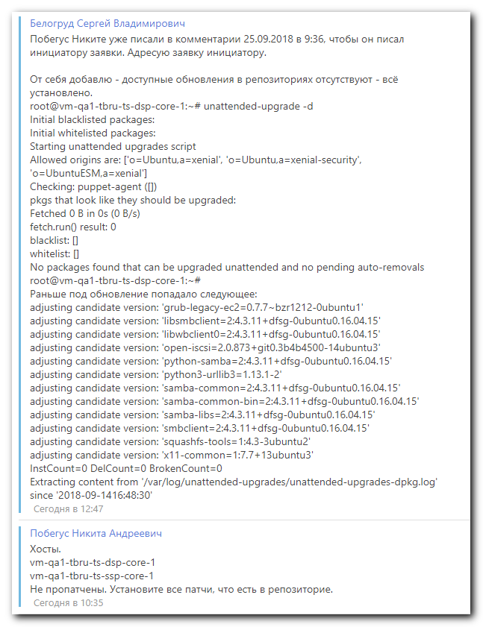

https://askubuntu.com/questions/194/how-can-i-install-just-security-updates-from-the-command-line

How can I install just security updates from the command line?
Ask Question
up vote
286
down vote
favorite
122
sudo apt-get upgrade installs all updates, not just security updates. I know that I can use Update Manager to select only important security updates, but is there a way to do this from the command line?

command-line
package-management
updates
security
shareimprove this question
edited Feb 14 '16 at 19:30

muru
130k19273463
asked Jul 28 '10 at 22:50

mac9416
15.2k63446
2
I don't think so. dist-upgrade takes the entire system to a new release. I'm talking about day-to-day updates, like the ones you see in Update Manager. – mac9416 Jul 28 '10 at 22:59
1
Oh, I see what you're saying now. Heh, I run apt-get update so often, I type it without thinking. Thanks for the heads-up! – mac9416 Jul 28 '10 at 23:02
7
You want "apt-get dist-upgrade", not "apt-get upgrade". "dist-upgrade" isn't for new releases (that's "do-release-upgrade" a separate command). Using "dist-upgrade" means it will handle changing dependencies of the new packages. This can be important. – Kees Cook Sep 21 '10 at 18:37
3
dist-upgrade is the normal operation performed by the Update Manager GUI. For packages such as the kernel where there is a linux-image-generic package, depending on the current image, eg linux-image-3.x.y-zz-generic (each version of which is a separate package name), dist-upgrade (which allows new packages to be installed to satisfy dependencies) will perform this upgrade, whereas upgrade will show the kernel package as held-back. – chronitis Nov 16 '12 at 14:25
3
Surprising that there are no good apt-get based answers for this, considering how prominently it is listed on each server – Karthik T Oct 29 '13 at 1:30
show 4 more comments
7 Answers
active oldest votes
up vote
267
down vote
accepted
The package unattended-upgrades provides functionality to install security updates automatically.

You could use this, but instead of configuring the automatic part you could call it manually. For this case, the following should do it quietly:

sudo unattended-upgrade
or more verbose version, for controlling how it goes

sudo unattended-upgrade -d
NOTE: When you call unattended-upgrade you leave the "s" off the end.

This assumes that the package is installed by default, which it probably is. If not, just do:

sudo apt-get install unattended-upgrades
See also /usr/share/doc/unattended-upgrades/README.md.

shareimprove this answer
edited May 20 at 4:18

jorfus
1476
answered Jul 29 '10 at 17:28

blueyed
5,93422131
For disabling the automatic execution of unattended-upgrade you are probably needing to modify /etc/cron.daily/apt, but not sure it is "correct" to do so – Jaime Hablutzel Oct 23 '14 at 3:33
side note: for Ubuntu 12.04.5 LTS server, unattended-upgrades is not installed by default. – Raptor Apr 22 '15 at 2:41
11
Since you're doing this from the command line, use -v for info messages or -d for debug messages. Otherwise the utility will be very silent, in which case you would need to check the logs in /var/log/unattended-upgrades. You can also use --dry-run to simulate but not actually upgrade anything. For more info and other options, use --help to get the help message. – ADTC Mar 20 '16 at 9:00
i learned a few things about unattended-upgrades today. thanks! – the0ther May 17 '16 at 18:19
"for monitoring how it goes", it is just debug non-interactive messages right? – Aquarius Power May 14 '17 at 21:12
add a comment
up vote
104
down vote
A Few Tips On How To Manage Updates
This applies both to Debian and Ubuntu, but more specific instructions for Ubuntu follow.

Show security updates only :

apt-get -s dist-upgrade |grep "^Inst" |grep -i securi
or

sudo unattended-upgrade --dry-run -d
or

/usr/lib/update-notifier/apt-check -p
Show all upgradeable packages

apt-get -s dist-upgrade | grep "^Inst"
Install security updates only

apt-get -s dist-upgrade | grep "^Inst" |
grep -i securi | awk -F " " {'print $2'} |
xargs apt-get install
Notes:

Sometimes Ubuntu shows security updates as if they're coming from $release-updates repository. This is so, I'm told, because Ubuntu developers push security updates to $release-updates repository as well to expedite their availability.

If that's the case, you can do the following to show security updates only:

sudo sh -c 'grep ^deb /etc/apt/sources.list |
grep security > /etc/apt/sources.security.only.list'
and

apt-get -s dist-upgrade -o Dir::Etc::SourceList=/etc/apt/sources.security.only.list -o Dir::Etc::SourceParts=/dev/null |
grep "^Inst" | awk -F " " {'print $2'}
Check what services need to be restarted after package upgrades. Figure out what packages you are going to upgrade beforehand and schedule your restarts/reboots. The problem here is that unless you restart a service it still may be using an older version of a library (most common reason) that's been loaded into memory before you installed new package which fixes a security vulnerability or whatever.

checkrestart -v
However, keep in mind that checkrestart may list processes that shouldn't necessarily be restarted. For example, PostgreSQL service may be keeping in its memory reference to an already deleted xlog file, which isn't a valid reason to restart the service.

Therefore, another, more reliable, way to check this using standard utils is the following little bash script that I shamelessly stole from https://locallost.net/?p=233

It checks if running processes on a system are still using deleted libraries by virtue of keeping copies of those in active memory.

ps xh -o pid |
while read PROCID; do
grep 'so.* (deleted)$' /proc/$PROCID/maps 2> /dev/null
if [ $? -eq 0 ]; then
CMDLINE=$(sed -e 's/\x00/ /g' < /proc/$PROCID/cmdline)
echo -e "\tPID $PROCID $CMDLINE\n"
fi
done
shareimprove this answer
edited Jan 6 '16 at 9:05

lemonsqueeze
1,164815
answered Nov 16 '12 at 11:35

ILIV
1,152178
1
I notice only now this post. It is extremely precise. Thanks a lot (+1) – Danduk82 May 13 '16 at 7:59
where does 'checkrestart' come from? I can't find it in Ubuntu Trusty. I did find "needrestart" which looks like it would fit in your instructions? – Ben XO Aug 19 '16 at 11:29
It can be found in debian-goodies package: packages.debian.org/wheezy/debian-goodies. There's also needrestart. You can find both on Xenial by running: $apt-cache search checkrestart – ILIV Aug 20 '16 at 3:51
I get "E: Could not open lock file /var/lib/dpkg/lock - open (13: Permission denied)" even with sudo. Is this something specific to one of the updates or the commands you've provided? – Nathan Hornby Sep 30 '16 at 9:53
Most likely it's about an incorrect/abnormal termination of dpkg that left a lock file uncleared. Doesn't happen normally until, e.g. installation of a package doesn't finish successfully (full disk, etc.) You probably cannot run other apt-get and dpkg commands, can you? – ILIV Oct 1 '16 at 5:00
show 2 more comments
up vote
46
down vote
replace /etc/apt/preferences with the following:

Package: *
Pin: release a=lucid-security
Pin-Priority: 500

Package: *
Pin: release o=Ubuntu
Pin-Priority: 50
now a simple apt-get upgrade will upgrade all security updates only.

Why (and how) this works: The preferences file will pin all packages from Ubuntu distribution to priority 50, which will make them less desirable than already installed packages. Files originating from security repository are given the default (500) priority so they are considered for installation. This means that only packages that are considered more desirable than currently installed ones are security updates. More information about pinning in the apt_preferences manpage.

You can temporarily promote a certain distribution for updates with the --target-release option that works with apt-get and aptitude (at least) which will allow you pin certain releases so that they are eligible for upgrade.

If you wish to use this for scripts only and not make it default for the system, you can place the rules in to some other location and use this instead:

apt-get -o Dir::Etc::Preferences=/path/to/preferences_file upgrade
This will make apt look for the preferences file from a non-default location.

The preferences file given as an example doesn't apply to third party repositories, if you wish to pin those too you can use apt-cache policy to easily determine the required keys for pinning.

shareimprove this answer
edited Dec 18 '15 at 9:29

A.B.
65.9k12156242
answered Jul 29 '10 at 4:12

Ressu
8,04012927
Thanks for taking time for a thorough answer. I think I understand how it works. But when I create the /etc/apt/preferences file and run apt-get upgrade, it wants to upgrade all packages, not just security updates. The list upgrade before and after are exactly the same, except with /etc/apt/preferences it doesn't want to upgrade Leafpad, which I built from source and installed "by hand" with dpkg. It's very strange to me, but may mean something to you. – mac9416 Jul 29 '10 at 13:14
1
You can see what is going on with apt-cache policy command. Pick one of the packages that isn't getting a security fix and run apt-cache policy packagename. This will list the priorities for various versions. You should see various lines and different priorities. If there are no lines with the priority 50, the pinning isn't affecting the packages in question for some reason. – Ressu Jul 29 '10 at 16:24
1
I had followed this answer in the past. Today I found out that due to this answer, 68 security update packages were NOT installed on my server and didn't show up as potential install candidates. This is NOT A GOOD ANSWER! – Shade Aug 22 '14 at 8:33
add a comment
up vote
9
down vote
The following is confirmed in Ubuntu 14.04 LTS.

Use the unattended-upgrade package.

Look at the file /etc/apt/apt.conf.d/50unattended-upgrades. There should be a section at the top that is:

// Automatically upgrade packages from these (origin:archive) pairs
Unattended-Upgrade::Allowed-Origins {
"${distro_id}:${distro_codename}-security";
// "${distro_id}:${distro_codename}-updates";
// "${distro_id}:${distro_codename}-proposed";
// "${distro_id}:${distro_codename}-backports";
};
Note how it has been configured to only allow unattended upgrades for security packages, by default.

Modify the file /etc/apt/apt.conf.d/10periodic similar to:

APT::Periodic::Update-Package-Lists "1";
APT::Periodic::Download-Upgradeable-Packages "1";
APT::Periodic::AutocleanInterval "7";
APT::Periodic::Unattended-Upgrade "1";
This will run automatic unattended security upgrades, once per day.

Now, to run manually: sudo unattended-upgrade.

To test as a dry-run, without doing anything: sudo unattended-upgrade --dry-run.

Source: https://help.ubuntu.com/14.04/serverguide/automatic-updates.html

shareimprove this answer
edited May 23 '17 at 22:12
answered Oct 3 '16 at 17:18

vcardillo
252138
Is there a way to make this a monthly schedule? – mike.b93 Feb 1 '17 at 14:30
1
@mike.b93, I believe setting APT::Periodic::Unattended-Upgrade "30"; Would do this--every 30 days. – vcardillo May 23 '17 at 22:13
add a comment
up vote
5
down vote
Although its pretty ugly, you could disable all the repositories apart from the security repository and then do:

sudo apt-get update && sudo apt-get upgrade
I haven't tested it, but in theory it would only find updates in the security repo and apply them...

shareimprove this answer
answered Jul 29 '10 at 0:00

Stephen RC
2,23462644
Yeah, that's a possibility. I'll look into it. I'm no good at BASH, but I may try to make a script to do it. – mac9416 Jul 29 '10 at 0:07
OK, I disabled all but the Ubuntu security repos and ran a sudo apt-get update && sudo apt-get upgrade (cancelling before any upgrades were done). Then I re-enabled all my repos, ran sudo apt-get updatee, and opened Update Manager. The packages marked as security updates were not exactly what apt-get upgrade found, but they were very close -- close enough for me. I still wish I knew exactly how Update Manager does it and how to do the same from the command-line, but this will do. Thanks! – mac9416 Jul 29 '10 at 0:39
add a comment
up vote
3
down vote
apt-get update: just read the entries in repository - acording to existing list. Needed to check what is new.
apt-get upgrade: all updates for installed packages without kernel modules. No release update.
apt-get dist-upgrade: all updates for installed packages also with kernel modules. No release update.
apt-get with parameter -s: test only, no changes performed.
shareimprove this answer
edited Aug 2 '13 at 10:11

Eric Carvalho
40k17109143
answered Aug 2 '13 at 9:49

fuser
471
add a comment
up vote
0
down vote
I can't find an option in either apt-get or aptitude, however someone had the same question on SuperUser. The only response is:

Check and adjust /etc/apt/apt.conf.d/50unattended-upgrade . Did you replace 'karmic' with the code name of your Ubuntu?

No reply as to whether that worked however.

shareimprove this answer
edited Mar 20 '17 at 10:18

Community♦
1
answered Jul 28 '10 at 23:04

Ross
87731122
2
It appears that the method described in that wiki page depends on setting aptitude's --target-release argument to <release>-security. Like the OP of that question, that method installs all upgrades, not just security upgrades. Reading the apt-get and aptitude man pages, I don't think the --target-release argument is even intended to limit upgrades to just security, though I'm not sure just what it is for. – mac9416 Jul 28 '10 at 23:38

https://tecadmin.net/install-security-updates-ubuntu-debian/

How to Install Security Updates in Ubuntu & Debian
Updated on July 10, 2016 by Rahul K.
Debian, LinuxMint, Ubuntu packages, security, Updates
For Debian based systems package unattended-upgrades provides functionality to install security updates only on your Debian systems. You can also configure your system to install security updates automatically.

Install Required Package
Default unattended-upgrades package should be installed on your system. But in case it’s not installed use following command to install.

$ sudo apt-get install unattended-upgrades
Install Security Updates
You can simply execute the following command to install security updates on your system. The below command will run silently on your system and apply security updates.

$ sudo unattended-upgrades
Or you can use optin -d with command to show verbose logs of update process.

$ sudo unattended-upgrades -d

#
# 20200812
#
https://linoxide.com/linux-how-to/install-security-updates-ubuntu/

How to Manually Install Security Updates on Ubuntu 18.04
Updated August 3, 2020By Jamie ArthurLINUX HOWTO, SECURITY

One of the most crucial tasks that a systems administrator needs to undertake is ensuring that systems are patched with the latest security updates. Ubuntu is considered as one of the most secure Linux distributions but it can be susceptible to vulnerabilities as well. An updated system is secure and stands a better chance against malware and attackers.
In this tutorial, we'll focus on how one can manually install security updates in Ubuntu 18.04.

List Security Updates
To display security updates only ,
sudo unattended-upgrade --dry-run -d
Or
apt-get -s dist-upgrade| grep "^Inst" | grep -i security
If you wish to display all upgradeable packages run
apt-get -s dist-upgrade | grep "^Inst"
Sample Output
Inst libplymouth4 [0.9.2-3ubuntu13.4] (0.9.2-3ubuntu13.5 Ubuntu:16.04/xenial-upd ates [amd64])
Inst plymouth [0.9.2-3ubuntu13.4] (0.9.2-3ubuntu13.5 Ubuntu:16.04/xenial-updates [amd64]) [plymouth-theme-ubuntu-text:amd64 ]
Inst plymouth-theme-ubuntu-text [0.9.2-3ubuntu13.4] (0.9.2-3ubuntu13.5 Ubuntu:16 .04/xenial-updates [amd64])
Finally, to install security updates only, run
apt-get -s dist-upgrade | grep "^Inst" | grep -i securi | awk -F " " {'print $2'} | xargs apt-get install

Manually Install Security Updates
To manually configure a system for security updates,
First, install unattended-upgrade package
apt-install unattended-upgrades
Sample Output
Reading package lists... Done
Building dependency tree
Reading state information... Done
unattended-upgrades is already the newest version (0.90ubuntu0.9).
0 upgraded, 0 newly installed, 0 to remove and 3 not upgraded.
After successful installation, you can proceed and call it manually as shown
sudo unattended-upgrade -d -v
Output
Initial blacklisted packages:
Initial whitelisted packages:
Starting unattended upgrades script
Allowed origins are: ['o=Ubuntu,a=xenial', 'o=Ubuntu,a=xenial-security', 'o=UbuntuESM,a=xenial']
adjusting candidate version: 'libplymouth4=0.9.2-3ubuntu13'
adjusting candidate version: 'plymouth=0.9.2-3ubuntu13'
adjusting candidate version: 'plymouth-theme-ubuntu-text=0.9.2-3ubuntu13'
pkgs that look like they should be upgraded:
Fetched 0 B in 0s (0 B/s)
fetch.run() result: 0
blacklist: []
whitelist: []
No packages found that can be upgraded unattended and no pending auto-removals

The -v flags prints out the process in verbose on a command line.
The -d handle debug messages in the system.

Setting up Automatic security updates
To configure your system to receive automatic security updates, follow the steps below

1. Install Unattended upgrade packages
To install unattended upgrades. First, log in as root and update the system
apt update
Next, install unattended-upgrades
apt install unattended-upgrades

2. Configure your Ubuntu system
After installation of Unattended updates, it's time now to configure your system.
Open the unattended upgrade configuration file as shown
vim/etc/apt/apt.conf.d/50unattended-upgrades
Comment out all line except the one with the security attribute as shown
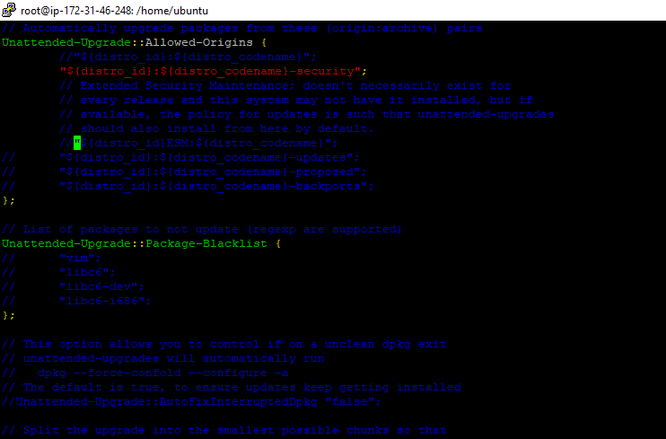
If you wish to exclude packages from being upgraded unattended, you can do so in the file configuration file under the Unattended-Upgrade::Package-Blacklist section.
Append each package on each line as shown
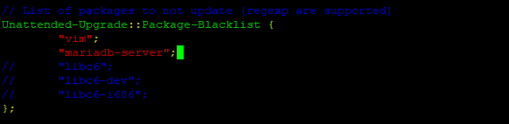
In the example above, vim text editor and MariaDB-server packages have been excluded. Save and Exit the configuration file.

3. Enable auto updating
Finally, you need to open the unattended-upgrades attributes
vim /etc/apt/apt.conf.d/20auto-upgrades

Save and Exit.
Reboot your system for the changes to take effect.
In this brief article, we have taken you through how to automatically and manually install security updates in Ubuntu 18.04. You are welcome to try out the above commands. Keep it locked for more insightful articles!

